CHURCH/NON PROFIT NAME

ONLINE GIVING
EASY TO MAKE ONE-TIME OR RECURRING DONATIONS ONLINE or REMITTANCE ENVELOPES

Online Giving Made Easy
Our hearts are with you as we all learn to navigate the new normal. We understand that there is a lot of information flooding your emails today about how to prepare for the future. As this may seem a bit overwhelming, please know that our virtual doors are open, always, and that we are here to help in any way possible.
We will continue to rely on the generosity of our members, donors, and congregation. We are happy to announce that we have partnered with our stewardship provider, NCS Solutions to launch an easy to use, online giving platform for our members.
We hope that you will consider a one-time donation or a recurring payment as more than ever when our physical doors are closed, we desire to survive and give back to the community that needs us most.

We are ready to go with our own Hosted Payment Page.
You can give today, (CHURCH INSERTS LINK HERE TO THE HOSTED PAYMENT PAGE)

Multiple ways to get started:
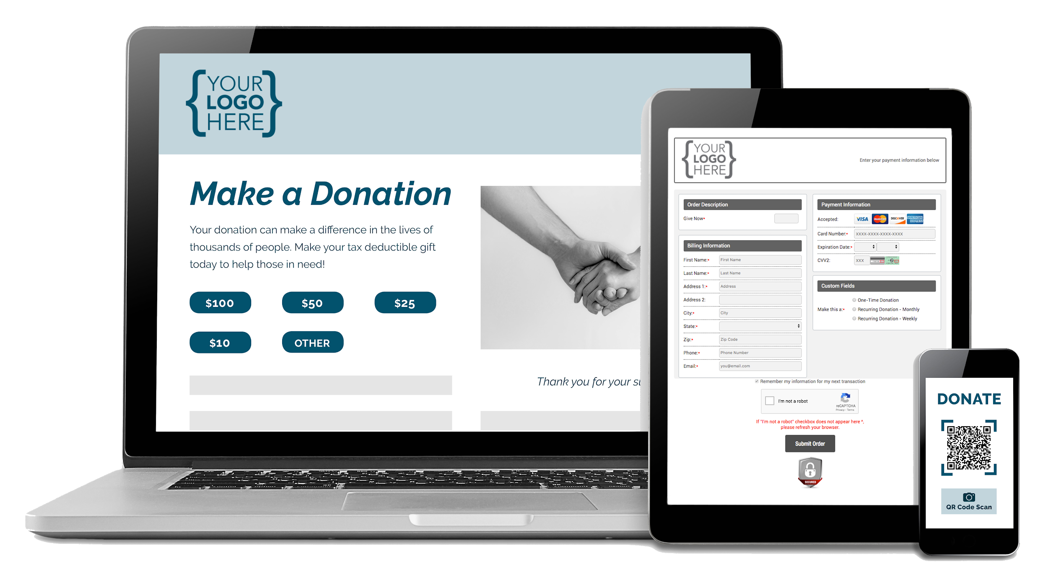
- Whether you elect to make a one-time donation, or would like to set up a recurring plan to meet a weekly obligation, know that the Donation Page securely stores payment information.
- You will notice that in an upcoming envelop mailing, that there will be a QR code that will take you directly to our Hosted Payment Page as well for easy access.
- You can visit our website at (CHURCH INSERTS WEB LINK HERE) where you will see a button “DONATE” to get started.
- Our Donation Page allows for flexible payments (credit card and e-check), next-day deposits so that we are keeping processing fees as low as possible.
- You can access our Donation Page from your desktop, tablet or mobile device.

If you have any questions, please contact us directly and we will help you to get started.
Together, let’s follow faith, not fear.
Insert Name Here
Insert email here
Insert phone here
Insert website here

